TOGAF® Architecture Deliverables, Phases C and D
Version 0.1 (Phases C and D draft), 2026-10-30
CSA Mentoring Unit Enterprise Architecture (A3)
Office of Student Mentoring (Mentoring Unit), Center for Student Affairs, University of Asia and the Pacific
Document Version History
Version  Number | Version  Date | Revised By | Description | Filename
0.1 | 2026-10-30 | Deejay Clark Datu | First draft of Phases C and D | 2026-10-30 - A3 Phase C-D - Architecture Deliverables.docx

Contents
1. Architectural Artifacts 4
1.1 Scope and Inputs 4
1.2 Selected Artifacts 4
2. Data Architecture 7
2.1 Baseline Data Architecture 7
2.2 Target Data Architecture 7
3. Application Architecture 11
3.1 Baseline Application Architecture 11
3.2 Target Application Architecture 12
4. Technology Architecture 14
4.1 Technology Portfolio Catalog (Baseline) 14
4.2 Technology Standards (Target) 14
5. Gap Analysis 15
5.1 Data Gaps 15
5.2 Application Gaps 15
5.3 Technology Gaps 15
Sources 16
Tracking Information
Project Name | CSA Mentoring Unit Enterprise Architecture (A3)
Prepared By | Deejay Clark Datu | Document Version No. | 0.1
Title | Architecture Deliverables, Phases C and D | Document Version Date | 2026-10-30
Reviewed By | Pending: Emmanuel Velasco, Aldrin | Review Date
Distribution List
From | Date | Phone/Email

To | Action* | Due Date | Phone//Email
* Action Types: Approve, Review, Inform, File, Action Required, Attend Meeting, Other (please specify)

Architectural Artifacts

Scope and Inputs
This document describes the Data, Application, and Technology Architectures (ADM Phases C and D) of the Office of Student Mentoring (OSM). It builds on the Phase B Architecture Requirements Specification and Architecture Roadmap, and uses the artifacts committed to in the team's Tailored Content Framework.
The scope covers OSM and its direct interfaces: the school Mentoring Coordinators, the Registrar, and the IT Office. How each school chooses a mentor for a student stays outside the scope. Only the hand-offs of lists and assignments are covered.
The work follows the team's Architecture Principles, especially Data Consistency and Accuracy (P2), Google Workspace as Primary Operations Tool (P3), and Confidentiality of the Mentoring Relationship (P4). In line with TOGAF, Phase C states what the application must do, and Phase D sets the technology standards it must meet. Choosing a specific product belongs to Phase E and is outside this document (The Open Group, 2022).

Selected Artifacts
Catalogs are lists of building blocks, matrices show how two kinds of building blocks relate, and diagrams are graphical views of the same content. The following artifacts were selected because they answer the unit's main concerns with the least reading.
Artifact | Phase | Section | Question it answers
Data Entity Catalog | C (Data) | 2.1, 2.2 | What data does the unit need, who owns it, and how sensitive is it?
Conceptual Data Diagram | C (Data) | 2.2 | How do pairings, sessions, and requests connect?
Data Entity / Business Capability Matrix | C (Data) | 2.2 | Which capability creates or changes each piece of data?
Application Portfolio Catalog | C (Application) | 3.1, 3.2 | What tools are used today, and what should replace them?
Application Communication Diagram | C (Application) | 3.1, 3.2 | How does information move between the tools?
Application / Business Capability Matrix | C (Application) | 3.2 | Which service supports each capability?
Technology Portfolio Catalog, with standards | D | 4 | What technology runs the tools, and what must the target follow?

Two adjustments were made to the TOGAF list. Business capabilities are used in place of business functions, to match Phase B. Data security is shown as a classification column in the Data Entity Catalog instead of a separate diagram. The full TOGAF list is shown below, with the selected artifacts in bold.
ADM Phase | Artifact
Preliminary Phase | Principles catalog
Phase A | Stakeholder Map matrix  Value Chain diagram  Solution Concept diagram  Business Model diagram  Business Capability map  Value Stream map
Phase B | Organization/Actor catalog  Driver/Goal/Objective catalog  Role catalog  Business Service/Function catalog  Location catalog  Process/Event/Control/Product catalog  Contract/Measure catalog  Business Capabilities catalog  Value Stream catalog  Value Stream Stages catalog  Business Interaction matrix  Actor/Role matrix  Value Stream/Capability matrix  Strategy/Capability matrix  Capability/Organization matrix  Business Footprint diagram  Business Service/Information diagram  Functional Decomposition diagram  Product Lifecycle diagram  Goal/Objective/Service diagram  Business Use-Case diagram  Organization Decomposition diagram  Process Flow diagram  Event diagram  Business Capability map (updated)  Value Stream map (updated)  Organization map
Phase C: Data Architecture | Data Entity/Data Component catalog  Data Entity/Business Function matrix  Application/Data matrix  Conceptual Data Diagram  Logical Data Diagram  Data Dissemination diagram  Data Security diagram  Data Migration diagram  Data Lifecycle diagram
Phase C: Application Architecture | Application Portfolio catalog  Interface catalog  Application/Organization matrix  Role/Application matrix  Application/Function matrix  Application Interaction matrix  Application Communication diagram  Application and User Location diagram  Application Use-Case diagram  Enterprise Manageability diagram  Process/Application Realization diagram  Software Engineering diagram  Application Migration diagram  Software Distribution diagram
Phase D | Technology Standards catalog  Technology Portfolio catalog  Application/Technology matrix  Environments and Locations diagram  Platform Decomposition diagram  Processing diagram  Networked Computing/Hardware diagram  Network and Communications diagram
Phase E | Project Context diagram  Benefits diagram
Requirements Management | Requirements catalog

Data Architecture

Baseline Data Architecture
The unit's mentoring data is spread across several spreadsheets, forms, and email threads kept by different people.
# | Data store | What it holds | Kept by | Problem
D1 | Enrolled Student List | Name, email, course, year level | Registrar (spreadsheet) | Reaches coordinators by two different routes
D2 | Master Pairing Database | Student number, name, program, year level, student email, mentor, mentor email, session count | OSM (Google Sheet) | Enrollment and year level are updated by hand
D3 | Session Log Sheet | Date, duration, venue, purpose, goal survey, mentor email, confirmation | IT Office script, used by OSM | Shared by several people; an admin email is kept as a backup
D4 | School Pairing Lists | Each coordinator's mentor-mentee list | Each school coordinator | Not linked to D2; last year's list was not saved
D5 | Mentor Change Requests | Request and reassignment | Email threads | No record or tracking
D6 | Mentor Capacity | How many more mentees a mentor can take | Email replies | Asked again every term
D7 | Mentor Approval Scorecard | Mentor evaluation | Supervisor, OpCom, ManCom | Confidential

The IT Office has linked D3 to D2, so confirmed sessions update the master database automatically. The main break is between D2 and the schools' own lists (D4). The unit's official record and the coordinators' working records can therefore disagree.

Target Data Architecture

Data Entity Catalog
Entity | Description | Data owner | Class
Student | Enrolled undergraduate (mentee) | Registrar (source), OSM | Confidential
Mentor | Approved mentor, internal or external, assigned through a school | OSM | Internal
School | Academic school | University | Public
Mentoring Coordinator | School staff who pair students | OSM | Internal
Academic Term | Semester and school year | Registrar | Public
Pairing | One student, one mentor, one term, with a status | OSM | Confidential
Mentor Capacity | Mentees a mentor will take this term | OSM | Internal
Mentor Change Request | A request to change mentor, with its status | OSM | Confidential
Session Log | A session recorded by the student and confirmed by the mentor | OSM | Confidential
Session Feedback | The short survey on whether the session met its goals | OSM | Confidential
Compliance Status | A student's confirmed sessions this term | OSM | Confidential
Mentor Approval Record | Scorecard and approval, held outside the platform | HR, ManCom | Confidential

Class key: Public means anyone may see it. Internal means university staff. Confidential means only those who need it to do their task (P4). Student data is handled under the Data Privacy Act of 2012.

Conceptual Data Diagram
The Pairing is the center of the target. Each session log and each mentor change request points to one recorded pairing instead of a typed-in mentor email, which closes the gap between OSM's records and the schools' lists.
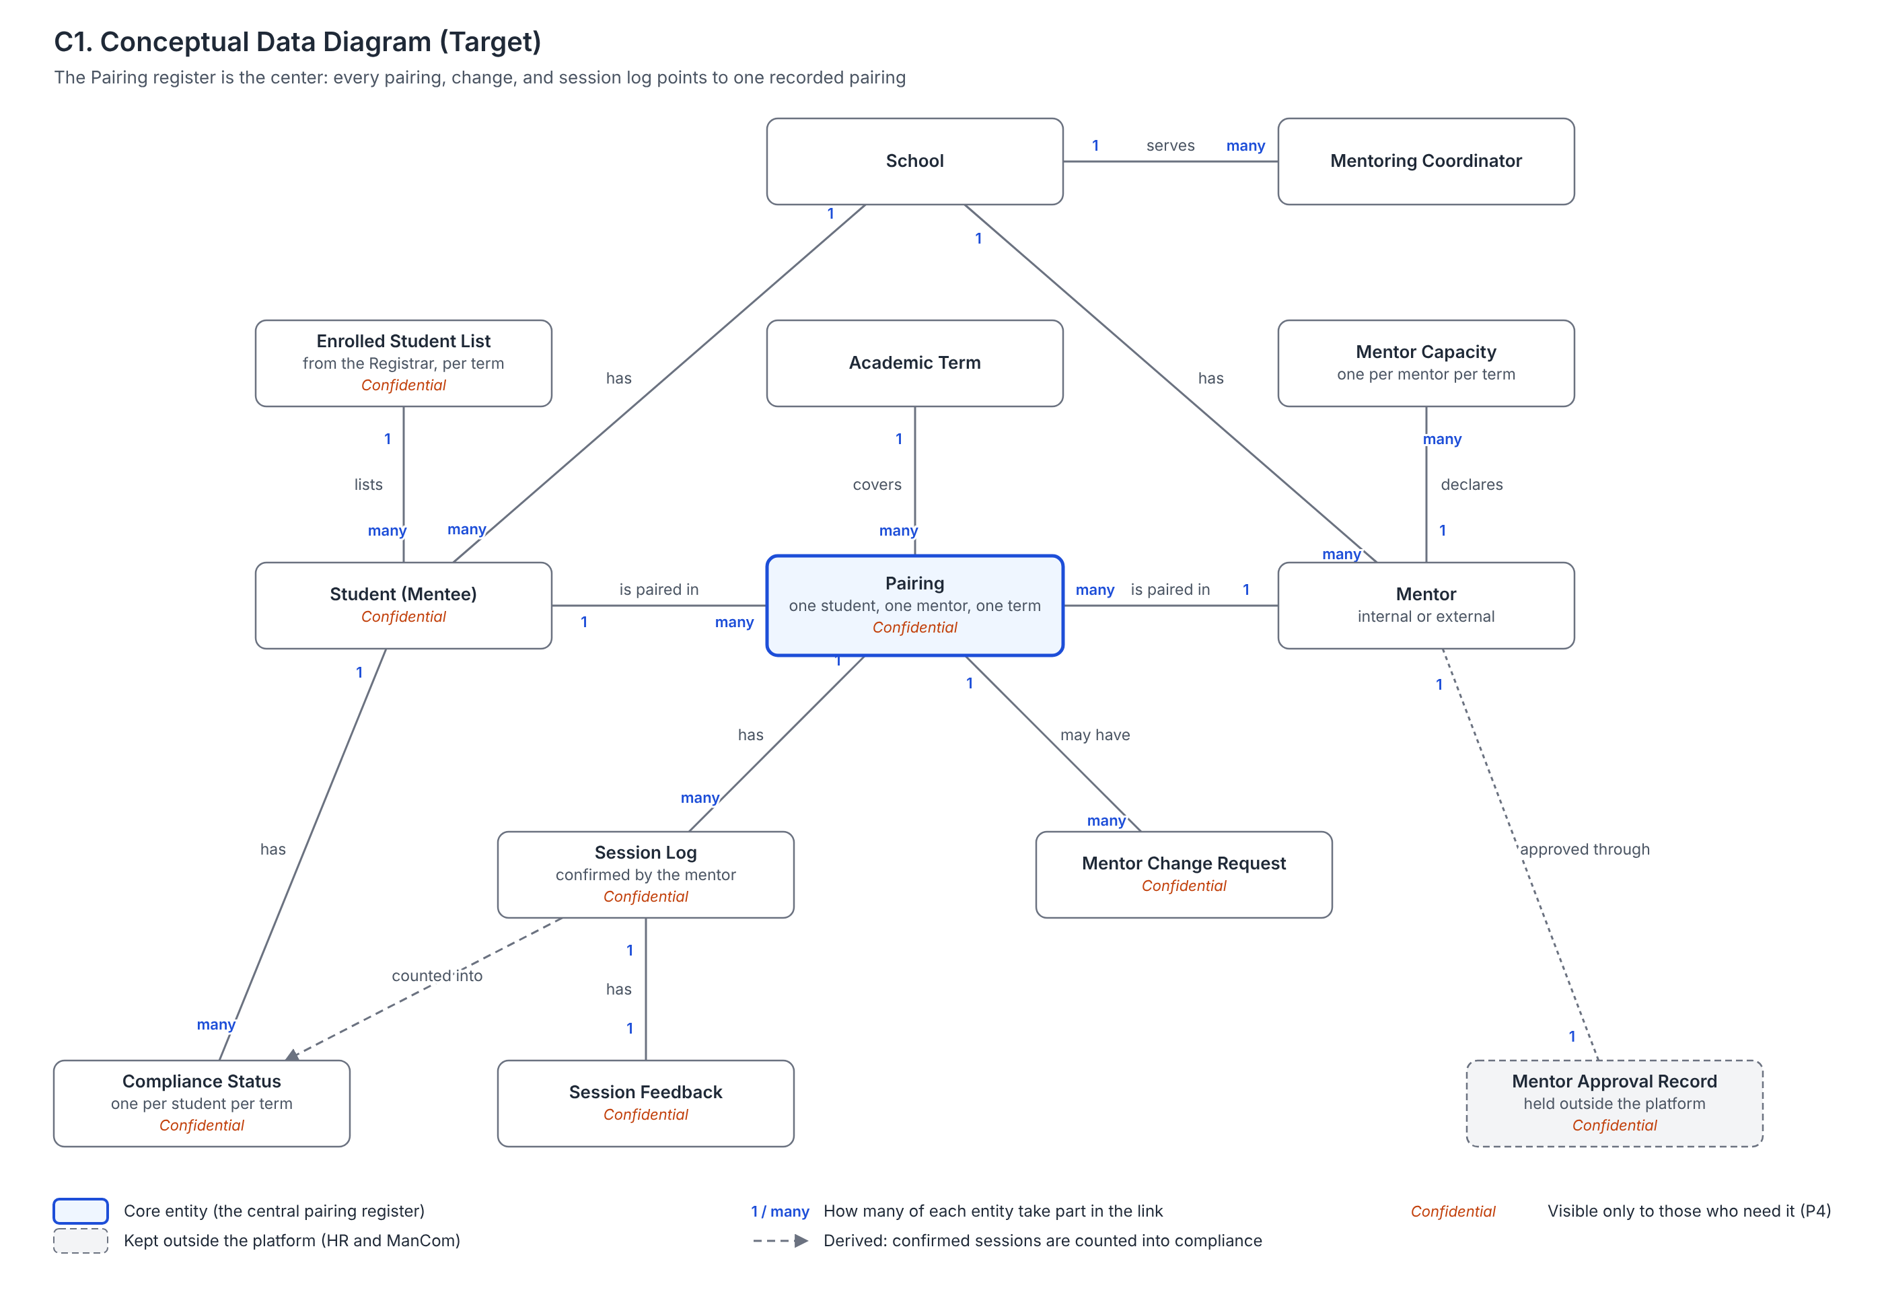
Figure 1. Conceptual Data Diagram (Target)

Data Entity / Business Capability Matrix
Entity | 1 Sourcing | 2 Develop. | 3 Pairing | 4 Change | 5 Logging | 6 Evaluation | 7 Promotion
Student |  |  | C U | R | R | R | R
Mentor | C U | R | R | R | R | R | R
Pairing |  |  | C | U | R | R
Mentor Capacity |  |  | C U | U |  | R
Mentor Change Request |  |  |  | C U |  | R
Session Log |  |  |  |  | C U | R
Session Feedback |  |  |  |  | C | R
Compliance Status |  |  |  |  | C U | R
Mentor Approval Record | C U

C = Create, R = Read, U = Update. Capabilities follow Phase B: (1) Mentor Sourcing and Approval, (2) Mentor Development, (3) Mentee-Mentor Pairing, (4) Pairing Change Management, (5) Session Logging and Compliance Monitoring, (6) Program Evaluation and Reporting, (7) Program Promotion.
Only Pairing creates a pairing record and only Pairing Change updates it, so the register has one clear owner. No entity is deleted: ended pairings are closed, not removed, so the pairing history is kept across terms. School, Mentoring Coordinator, and Academic Term are read by every capability and are maintained outside them.

Application Architecture

Baseline Application Architecture
The unit has no mentoring application of its own. Its work runs on general Google Workspace tools, joined together by email and by hand. A dedicated Mentoring Portal was used in earlier years and has been retired; session logging has since moved to a Google Form.

Application Portfolio Catalog (Baseline)
# | Application | Used for | Users | Maintained by
A1 | Session Log Form (Google Forms) | Students record sessions | Students | IT Office
A2 | Confirmation Script (Apps Script) | Emails the mentor a confirmation link, updates the sheet and the master database, copies to an admin email | Mentors, OSM | IT Office
A3 | Session Log Sheet and Master Pairing Database (Google Sheets) | OSM's official records | OSM | OSM
A4 | School pairing lists (spreadsheets) | Each coordinator's own pairings | Coordinators | Each coordinator
A5 | Retention survey (Google Forms) | Asks returning students whether to keep their mentor | Coordinators, students | Each coordinator
A6 | Email (Gmail) | Student lists, capacity checks, pairing notices, mentor changes | Everyone | Each user

The Registrar's student records are an external source. The list reaches the unit as a spreadsheet.

Application Communication Diagram (Baseline)
Only the session logging chain (A1, A2, A3) is automated. Every other step is an email or a manual copy, and the coordinators' lists (A4) have no link to OSM's records (A3).
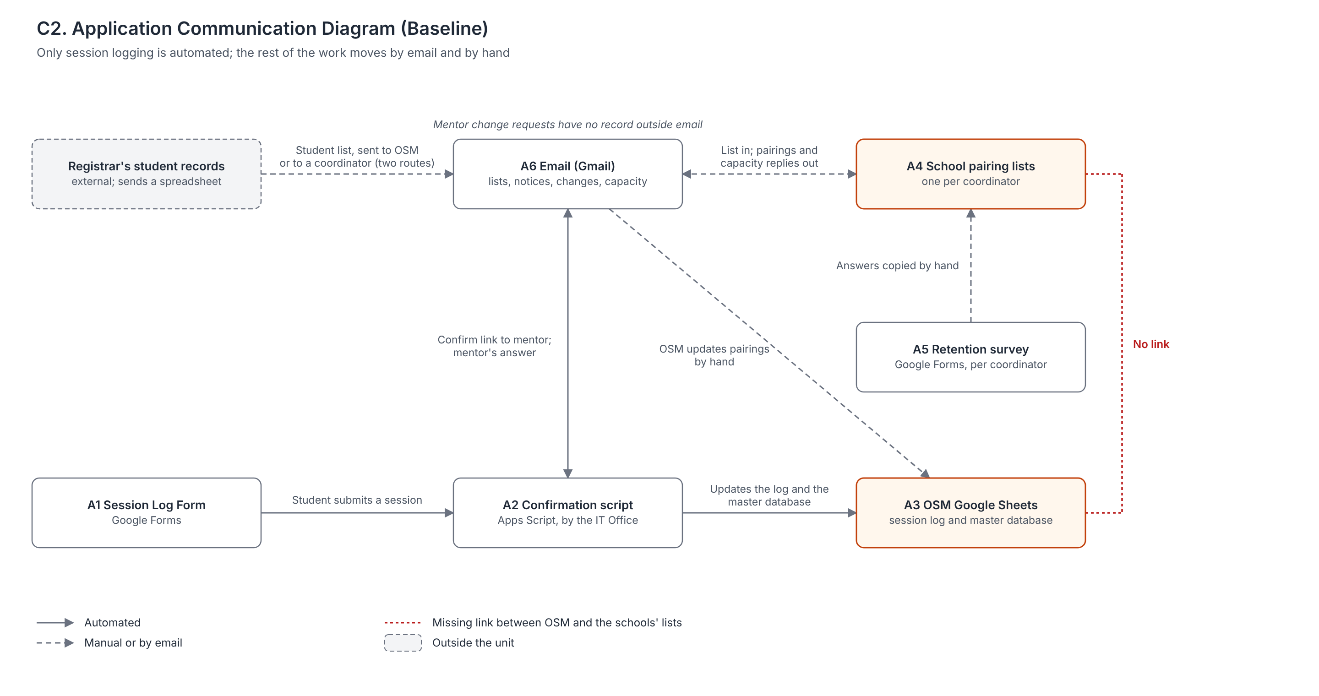
Figure 2. Application Communication Diagram (Baseline)

Target Application Architecture
The target replaces the email chains and separate lists with one Mentoring Management Application made up of five services. This section states what the application must do, not which product delivers it.

Application Portfolio Catalog (Target)
# | Application service | What it does | Users
S1 | Pairing Register | Imports the term's enrolled list, records mentor capacity and pairings, and keeps history across terms | OSM, coordinators
S2 | Mentor Change Requests | Takes requests in one tracked queue and updates the register when a change is approved | Students, mentors, OSM, coordinators
S3 | Session Logging | Students log sessions against their recorded pairing; mentors confirm by email link, which also works for external mentors | Students, mentors
S4 | Compliance Monitoring and Reporting | Counts confirmed sessions, flags students below three, and produces reports for the CSA Executive Director and ManCom | OSM, CSA Executive Director
S5 | Notifications | Sends pairing notices, change results, and reminders | All

School coordinators will use S1 directly. This is a new role for them under Principle P5, but S1 replaces the separate lists and emails they keep today, so their total work goes down.

Application Communication Diagram (Target)
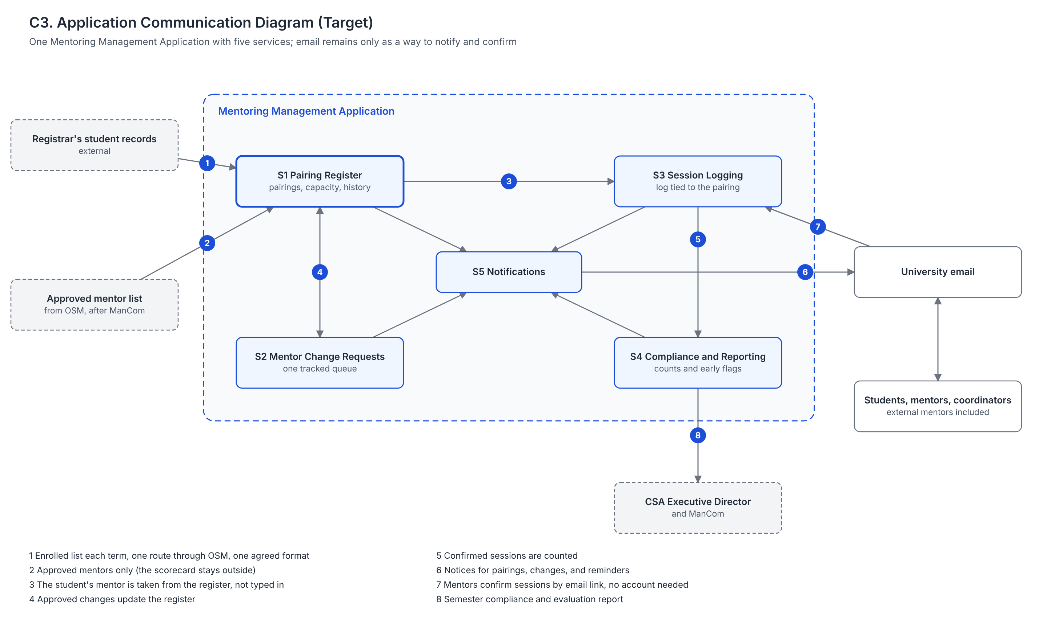
Figure 3. Application Communication Diagram (Target)

Application / Business Capability Matrix
Capability | S1 | S2 | S3 | S4 | S5
1 Mentor Sourcing and Approval | Reads the approved mentor list
2 Mentor Development
3 Mentee-Mentor Pairing | X |  |  |  | X
4 Pairing Change Management | X | X |  |  | X
5 Session Logging and Compliance |  |  | X | X | X
6 Program Evaluation and Reporting |  |  |  | X
7 Program Promotion |  |  |  |  | X

Mentor approval and mentor development stay with HR and ManCom. The application only receives the approved mentor list, which keeps the confidential scorecard out of it (P4).

Technology Architecture
The unit runs entirely on the university's Google Workspace, which UA&P already licenses and the IT Office supports. This section lists the current technology and sets the standards the target must meet. It does not choose a product.

Technology Portfolio Catalog (Baseline)
# | Technology | Role | Supported by
T1 | Google Workspace (Forms, Sheets, Gmail, Apps Script, Drive) | Runs every current application (A1 to A6) | IT Office
T2 | UA&P Google accounts | Sign-in for students, staff, and internal mentors | IT Office
T3 | Registrar's student records | Source of the enrolled student list, sent as a spreadsheet | Registrar
T4 | Web browser on personal laptops and phones | How every user reaches the tools | Each user

External mentors may not have UA&P accounts. They currently take part through email links only.

Technology Standards (Target)
# | Standard | Source
TS1 | The application runs within the university's Google Workspace where possible. Anything outside it needs an IT Office justification. | P3
TS2 | Students, coordinators, and OSM sign in with UA&P accounts. External mentors confirm sessions through email links without needing an account. | Interviews
TS3 | Access is by role, so Confidential data is visible only to those who need it. Student data is handled under the Data Privacy Act of 2012. | P4, RFAW
TS4 | The application works in a web browser on phones and laptops, with nothing to install. | P1
TS5 | The Registrar sends the enrolled list each term in one agreed format. | Phase B
TS6 | OSM owns the data, and the IT Office maintains the tools. | Phase B

All five application services (S1 to S5) are expected to run on T1 and T2.

Gap Analysis
Each table compares the baseline with the target. Keep means the item stays, Change means it is reworked, New means it does not exist today, and Eliminate means it is removed. These gaps feed the Information Systems and Technology components of the Architecture Roadmap.

Data Gaps
Baseline | Target | Action
School pairing lists not linked to OSM's database | One Pairing register | New
Last year's pairings not saved | Pairing history kept across terms | New
Session log tied to a typed mentor email | Session log tied to a Pairing | Change
Year level and enrollment updated by hand | Refreshed from each term's enrolled list | Change
Mentor changes and capacity kept only in email | Mentor Change Request and Mentor Capacity records | New
Confirmed sessions update the master database | Same | Keep
Scorecard kept outside, confidential | Same | Keep

Application Gaps
Baseline | Target | Action
Session Log Form and confirmation script (A1, A2) | S3 Session Logging, with the email-link confirmation kept | Keep and extend
Shared sheets plus a backup admin email (A3) | S1 and S4 with access by role | Change
Coordinator lists and retention surveys (A4, A5) | S1 Pairing Register | Eliminate
Email chains for notices and changes (A6) | S2 and S5 | Eliminate
Session counts with no early warning | S4 flags students below three sessions | New

Technology Gaps
Baseline | Target | Action
Google Workspace and UA&P accounts | Same | Keep
Several people can edit the shared sheets | Access by role (TS3) | Change
No agreed format for the Registrar list | One format each term (TS5) | New
No named owner for upkeep | OSM owns the data; the IT Office maintains the tools (TS6) | New

Sources
- Interview with the OSM Operations Coordinators, 2026-09-11.
- Interview with the OSM Operations Coordinators, 2026-09-28.
- Interview with the SSE Mentoring Coordinator, 2026-10-16.
- Interview with the SED Mentoring Coordinator, 2026-10-20.
- Phase B Architecture Requirements Specification and Architecture Roadmap, 2026-10-29.
- Enterprise Proposal (A1, revised): Principles Catalog, Tailored Content Framework, and Request for Architecture Work.
- The Open Group. (2022). The TOGAF Standard, 10th Edition: Introduction and Core Concepts. Van Haren Publishing.

